CT Suicide Advisory Board
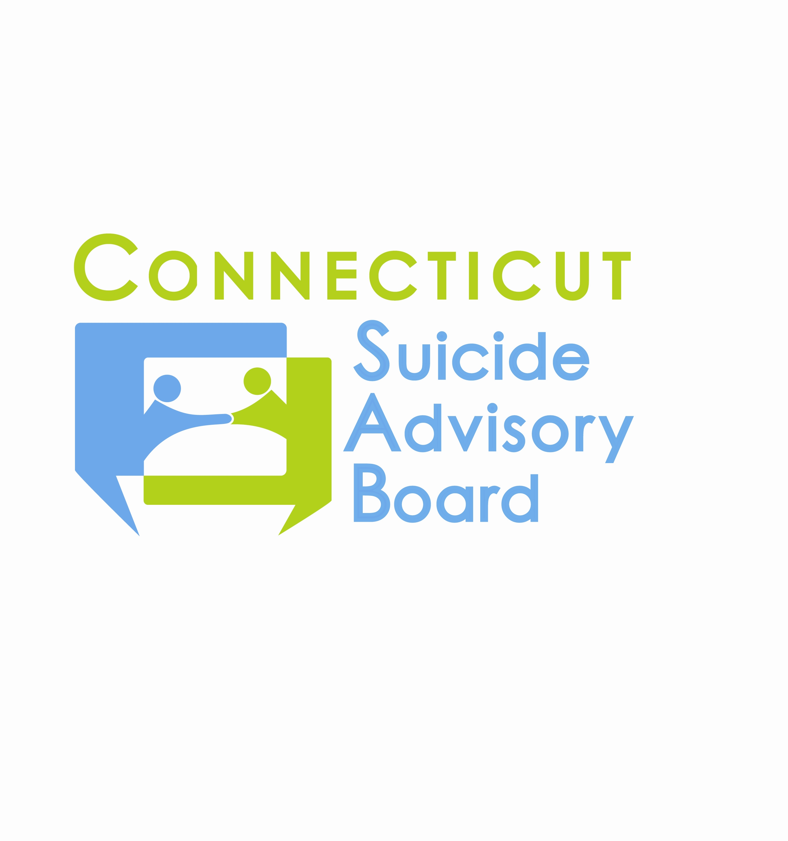
United Way of CT
1344 Silas Deane Highway, 4th Floor
Rocky Hill, Connecticut

October 11, 2012 9:00-11:00 AM

AGENDA

- Welcome & Introductions
- Updates regarding priority areas
- Awareness Campaign
  - Awareness Outreach
- Statewide Network
  - Website
- Evidence-Based Practice Promotion
  - GLS Grant Efforts
  - New DMHAS Training Catalogs
- State Plan Revision
- Other Business

- 2012 Meeting Schedule: 2nd Th. of each month from 9-11 AM at the United Way of CT, Rocky Hill, CT:
- 11/8 – Presentation on Connect USA and Crisis Chat, Mary Drexler
- 12/13 – Agenda TBD

