CT Suicide Advisory Board
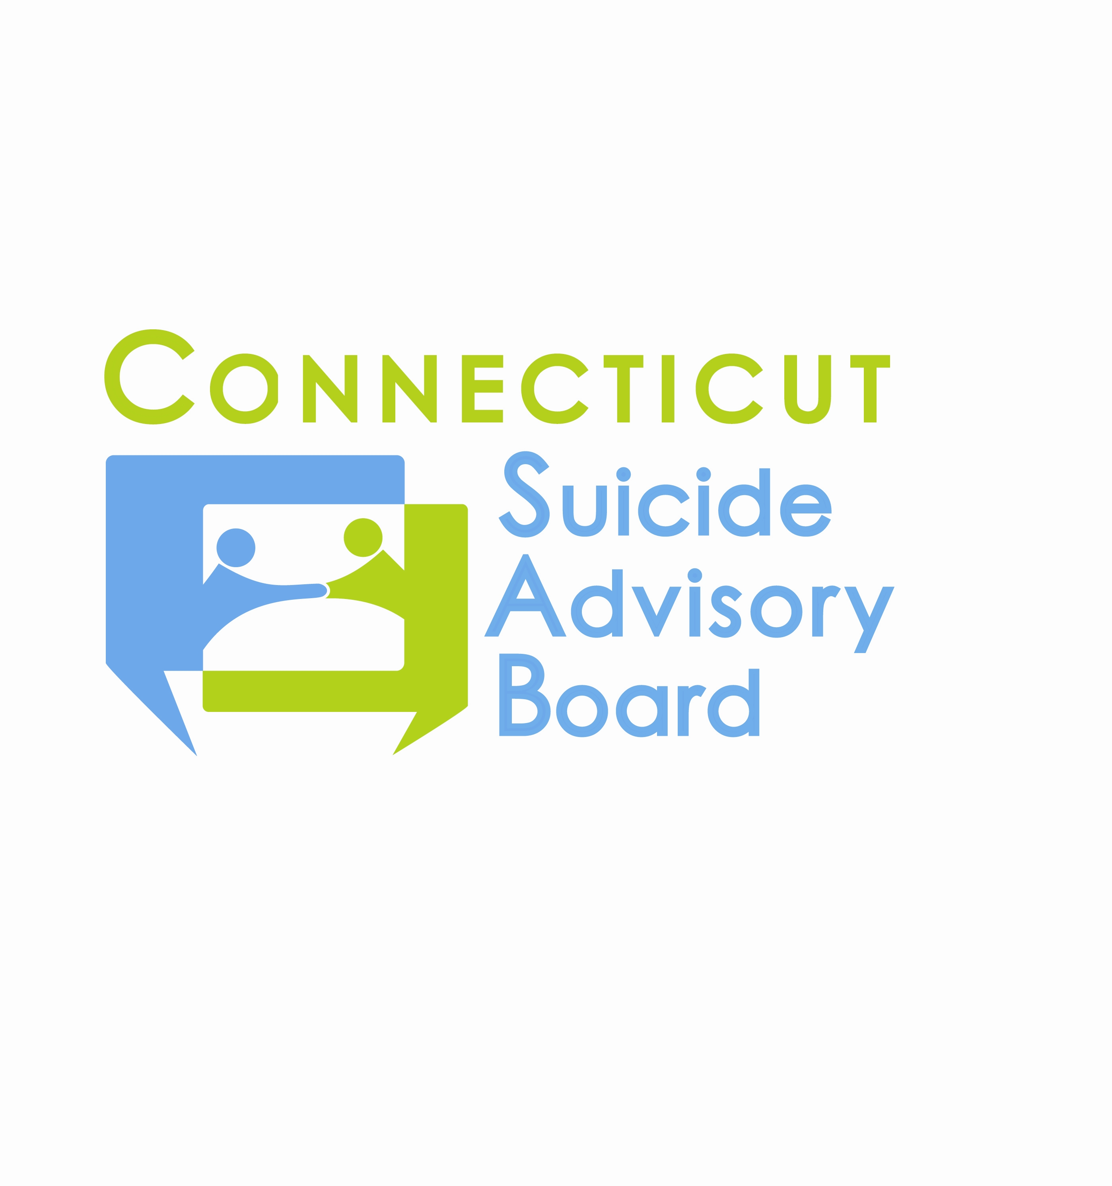
United Way of CT
1344 Silas Deane Highway, 4th Floor
Rocky Hill, Connecticut
August 8, 2013 9:00-11:00 AM

AGENDA

- Welcome & Introductions
- Presentation: Michelle Louise Bicking, Executive Director, Self Injury Awareness Network/ CT

- Review of 7/11/13 Minutes and Follow-up
- Updates regarding priority areas & sub-committees
- Awareness Campaign/Website
  - Website Calendar-Event Management
  - Materials/Marketing
- Statewide Network
  - September Planning Committee
    - 9/26 Annual Meeting
    - September- Suicide prevention month planning
- Evidence-Based Practice Promotion
  - Intervention-Postvention Response Committee
  - Armed Forces Committee
- State Plan
  - Updates
- Updates
- 2013 Meeting Schedule: 2nd Th. of each month from 9-11 AM at the United Way of CT, Rocky Hill, CT:
- 9/12 – Committee Meetings  9/26 - Annual Meeting, Rocky Hill Sheraton, 9-4 | - 10/10 Mui Mui Hin-McCormick, CT Asian Pacific American Affairs Commission  - 11/14  - 12/12

