CT Suicide Advisory Board
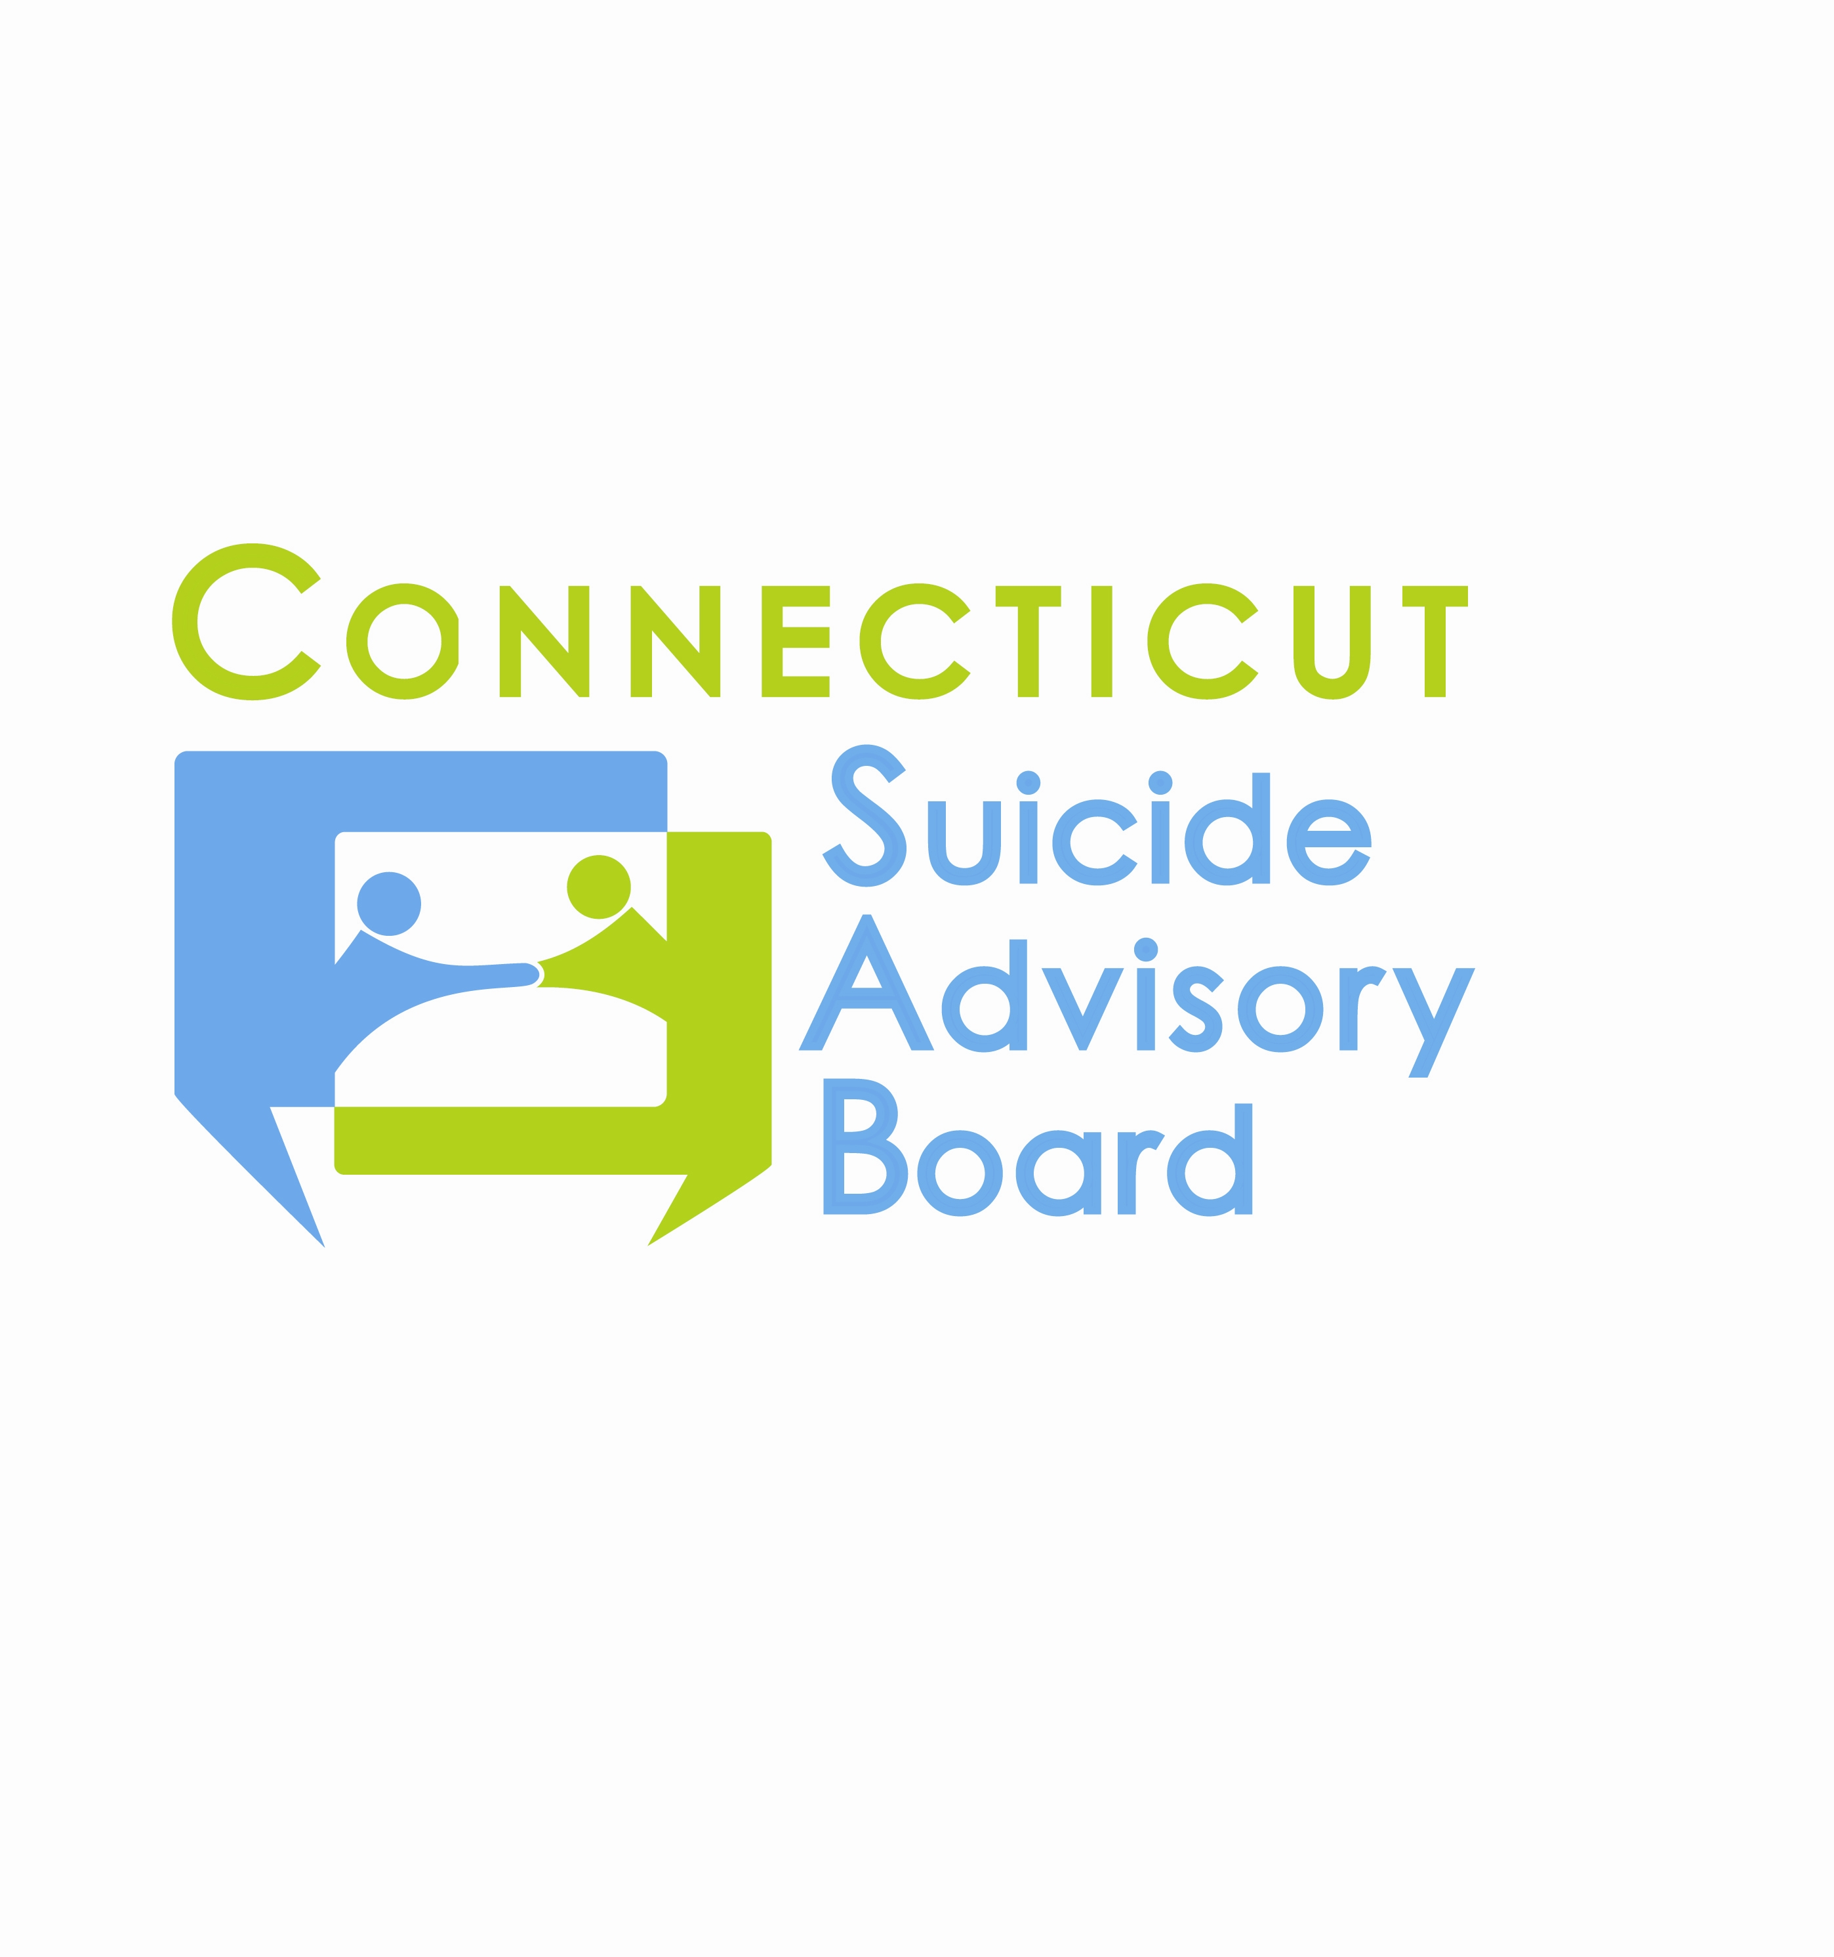
United Way of CT
1344 Silas Deane Highway, 4th Floor
Rocky Hill, Connecticut

July 12, 2012 9:00-11:00 AM

AGENDA

- Welcome & Introductions
- Final review of results from Strategic Planning Meeting on 5/10/12
- Updates regarding priority areas
- Awareness Campaign
  - Awareness Outreach
  - World Suicide Prevention Day Sept. 10, 2012 and National Suicide Prevention Week (Sept. 9-15, 2012) Activities
    - Press Conference 9/10/12 at 10:30 A.M.
    - Other
- Statewide Network
  - Website
- Evidence-Based Practice Promotion
  - GLS Campuses
  - Connect
  - QPR
- State Plan Revision
- Other Business

- 2012 Meeting Schedule: 2nd Th. of each month from 9-11 AM at the United Way of CT, Rocky Hill, CT:
- 8/9 (meeting for Press Conference Planning Committee)
- 9/13 – Special meeting in honor of National Suicide Prevention Week. Training in QPR Gatekeeper Program.
- 10/11, 11/8, 12/13 – Agendas TBD

