CT Suicide Advisory Board
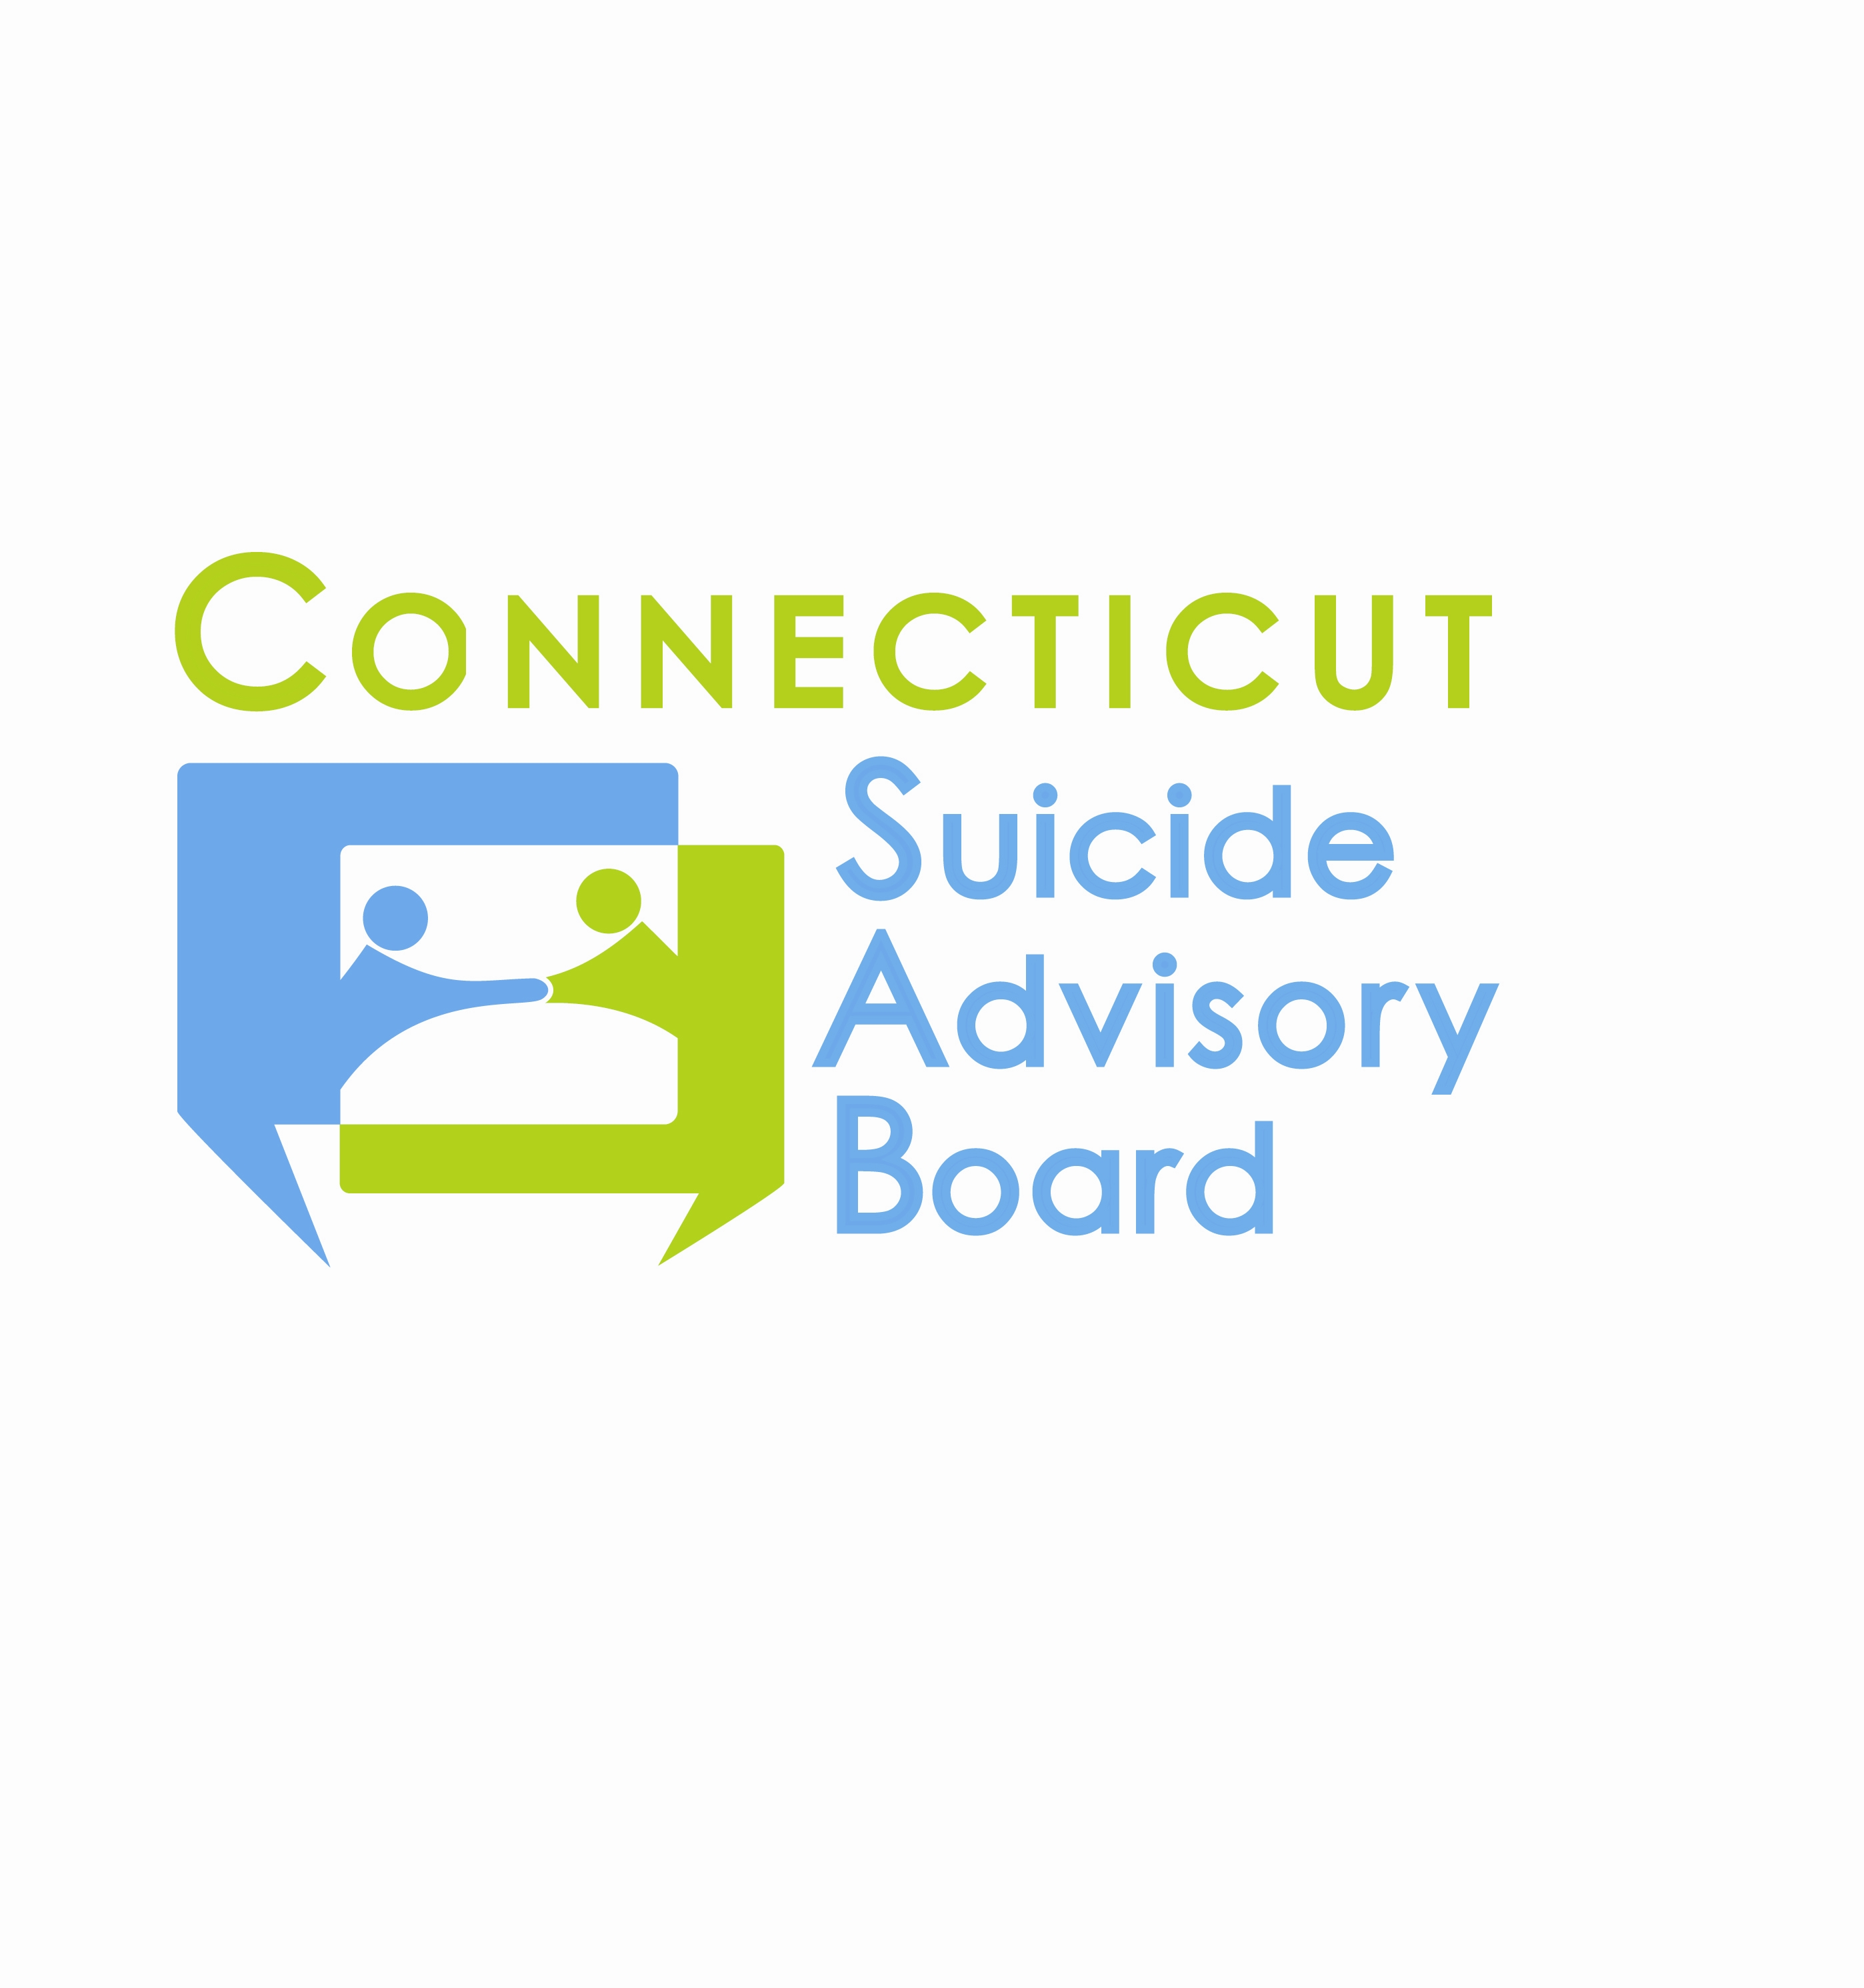
United Way of CT
1344 Silas Deane Highway, 4th Floor
Rocky Hill, Connecticut

June 14, 2012 9:00-11:00 AM

AGENDA

- Welcome & Introductions
- Presentation by Nina Rovinelli-Heller, UConn School of Social Work on her work with the National Action Alliance for Suicide Prevention on Clinical Workforce Preparation
- Review of results from Strategic Planning Meeting on 5/10/12
- Group sharing regarding priority areas
- Awareness Campaign
- Statewide Network
- State Plan Revision
- Evidence-Based Practice Promotion
- Activities for National Suicide Prevention Week (Sept. 9-15, 2012) and World Suicide Prevention Day Sept. 10, 2012
- Other Business

- 2012 Meeting Schedule: 2nd Th. of each month from 9-11 AM at the United Way of CT, Rocky Hill, CT:
- 7/12, 8/9 (meeting?) – Agendas TBD.
- 9/13 – Special meeting 9 AM-12:30 PM(?) in honor of National Suicide Prevention Week. Training opportunity in safeTALK or QPR Gatekeeper Program.
- 10/11, 11/8, 12/13 – Agendas TBD

