CT Suicide Advisory Board
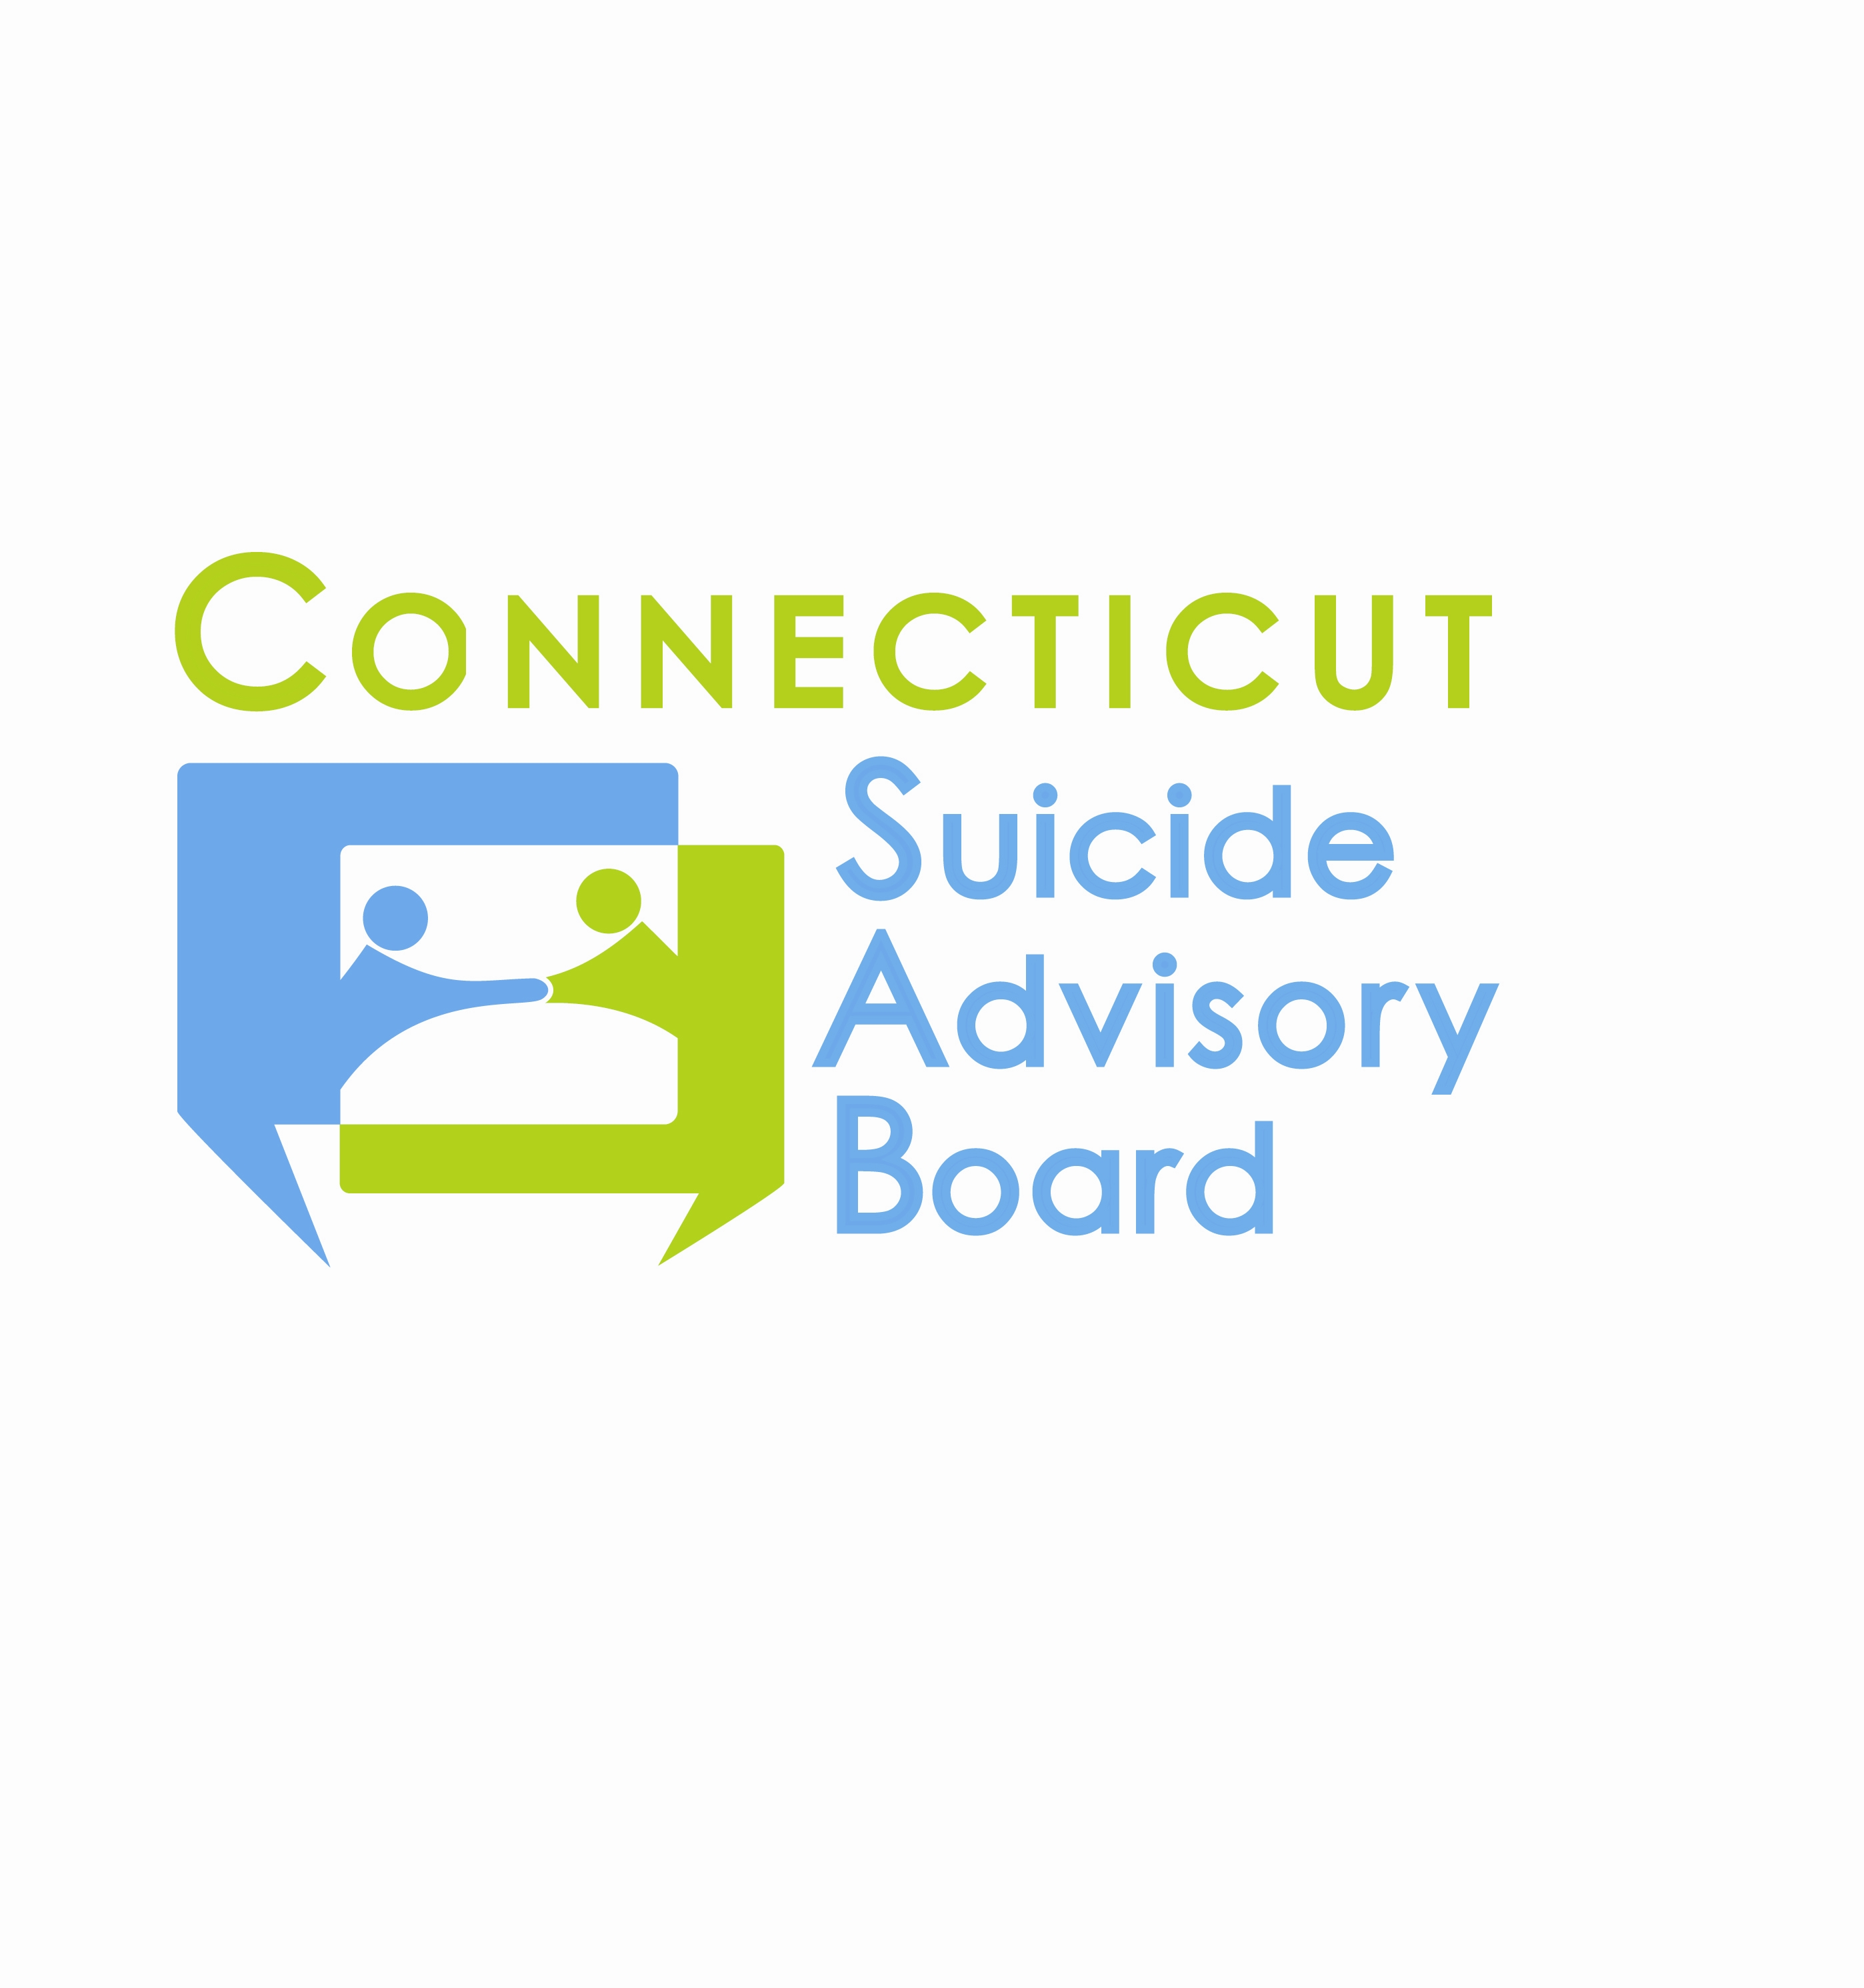
United Way of CT
1344 Silas Deane Highway, 4th Floor
Rocky Hill, Connecticut
June 13, 2013 9:00-11:00 AM

AGENDA

- Welcome & Introductions
- Presentation: Tom Steen, Director, Capitol Area Substance Abuse Action Council- Regional Action Councils and Community-level Suicide Prevention Efforts
- Review of 5/9/13 Minutes and Follow-up
- Updates regarding priority areas & sub-committees
- Awareness Campaign/Website
  - PSA/Radio Ad updates
- Statewide Network
  - Semi-formalization of Board and Network
  - Planning Committee
    - 9/26 Annual Meeting
    - Suicide prevention month planning
- Evidence-Based Practice Promotion
  - Training efforts and mini-grants. Postvention Planning in Enfield.
  - Intervention-Postvention Response Committee
  - Armed Forces Committee
- State Plan
  - Evaluation contract
  - Survey
- Updates
- 2013 Meeting Schedule: 2nd Th. of each month from 9-11 AM at the United Way of CT, Rocky Hill, CT:
- 7/11 – CT Military Support Program  - 8/8  - 9/12 - Meeting?  - 9/26 - Annual Meeting | - 10/10  - 11/14  - 12/12

