CT Suicide Advisory Board
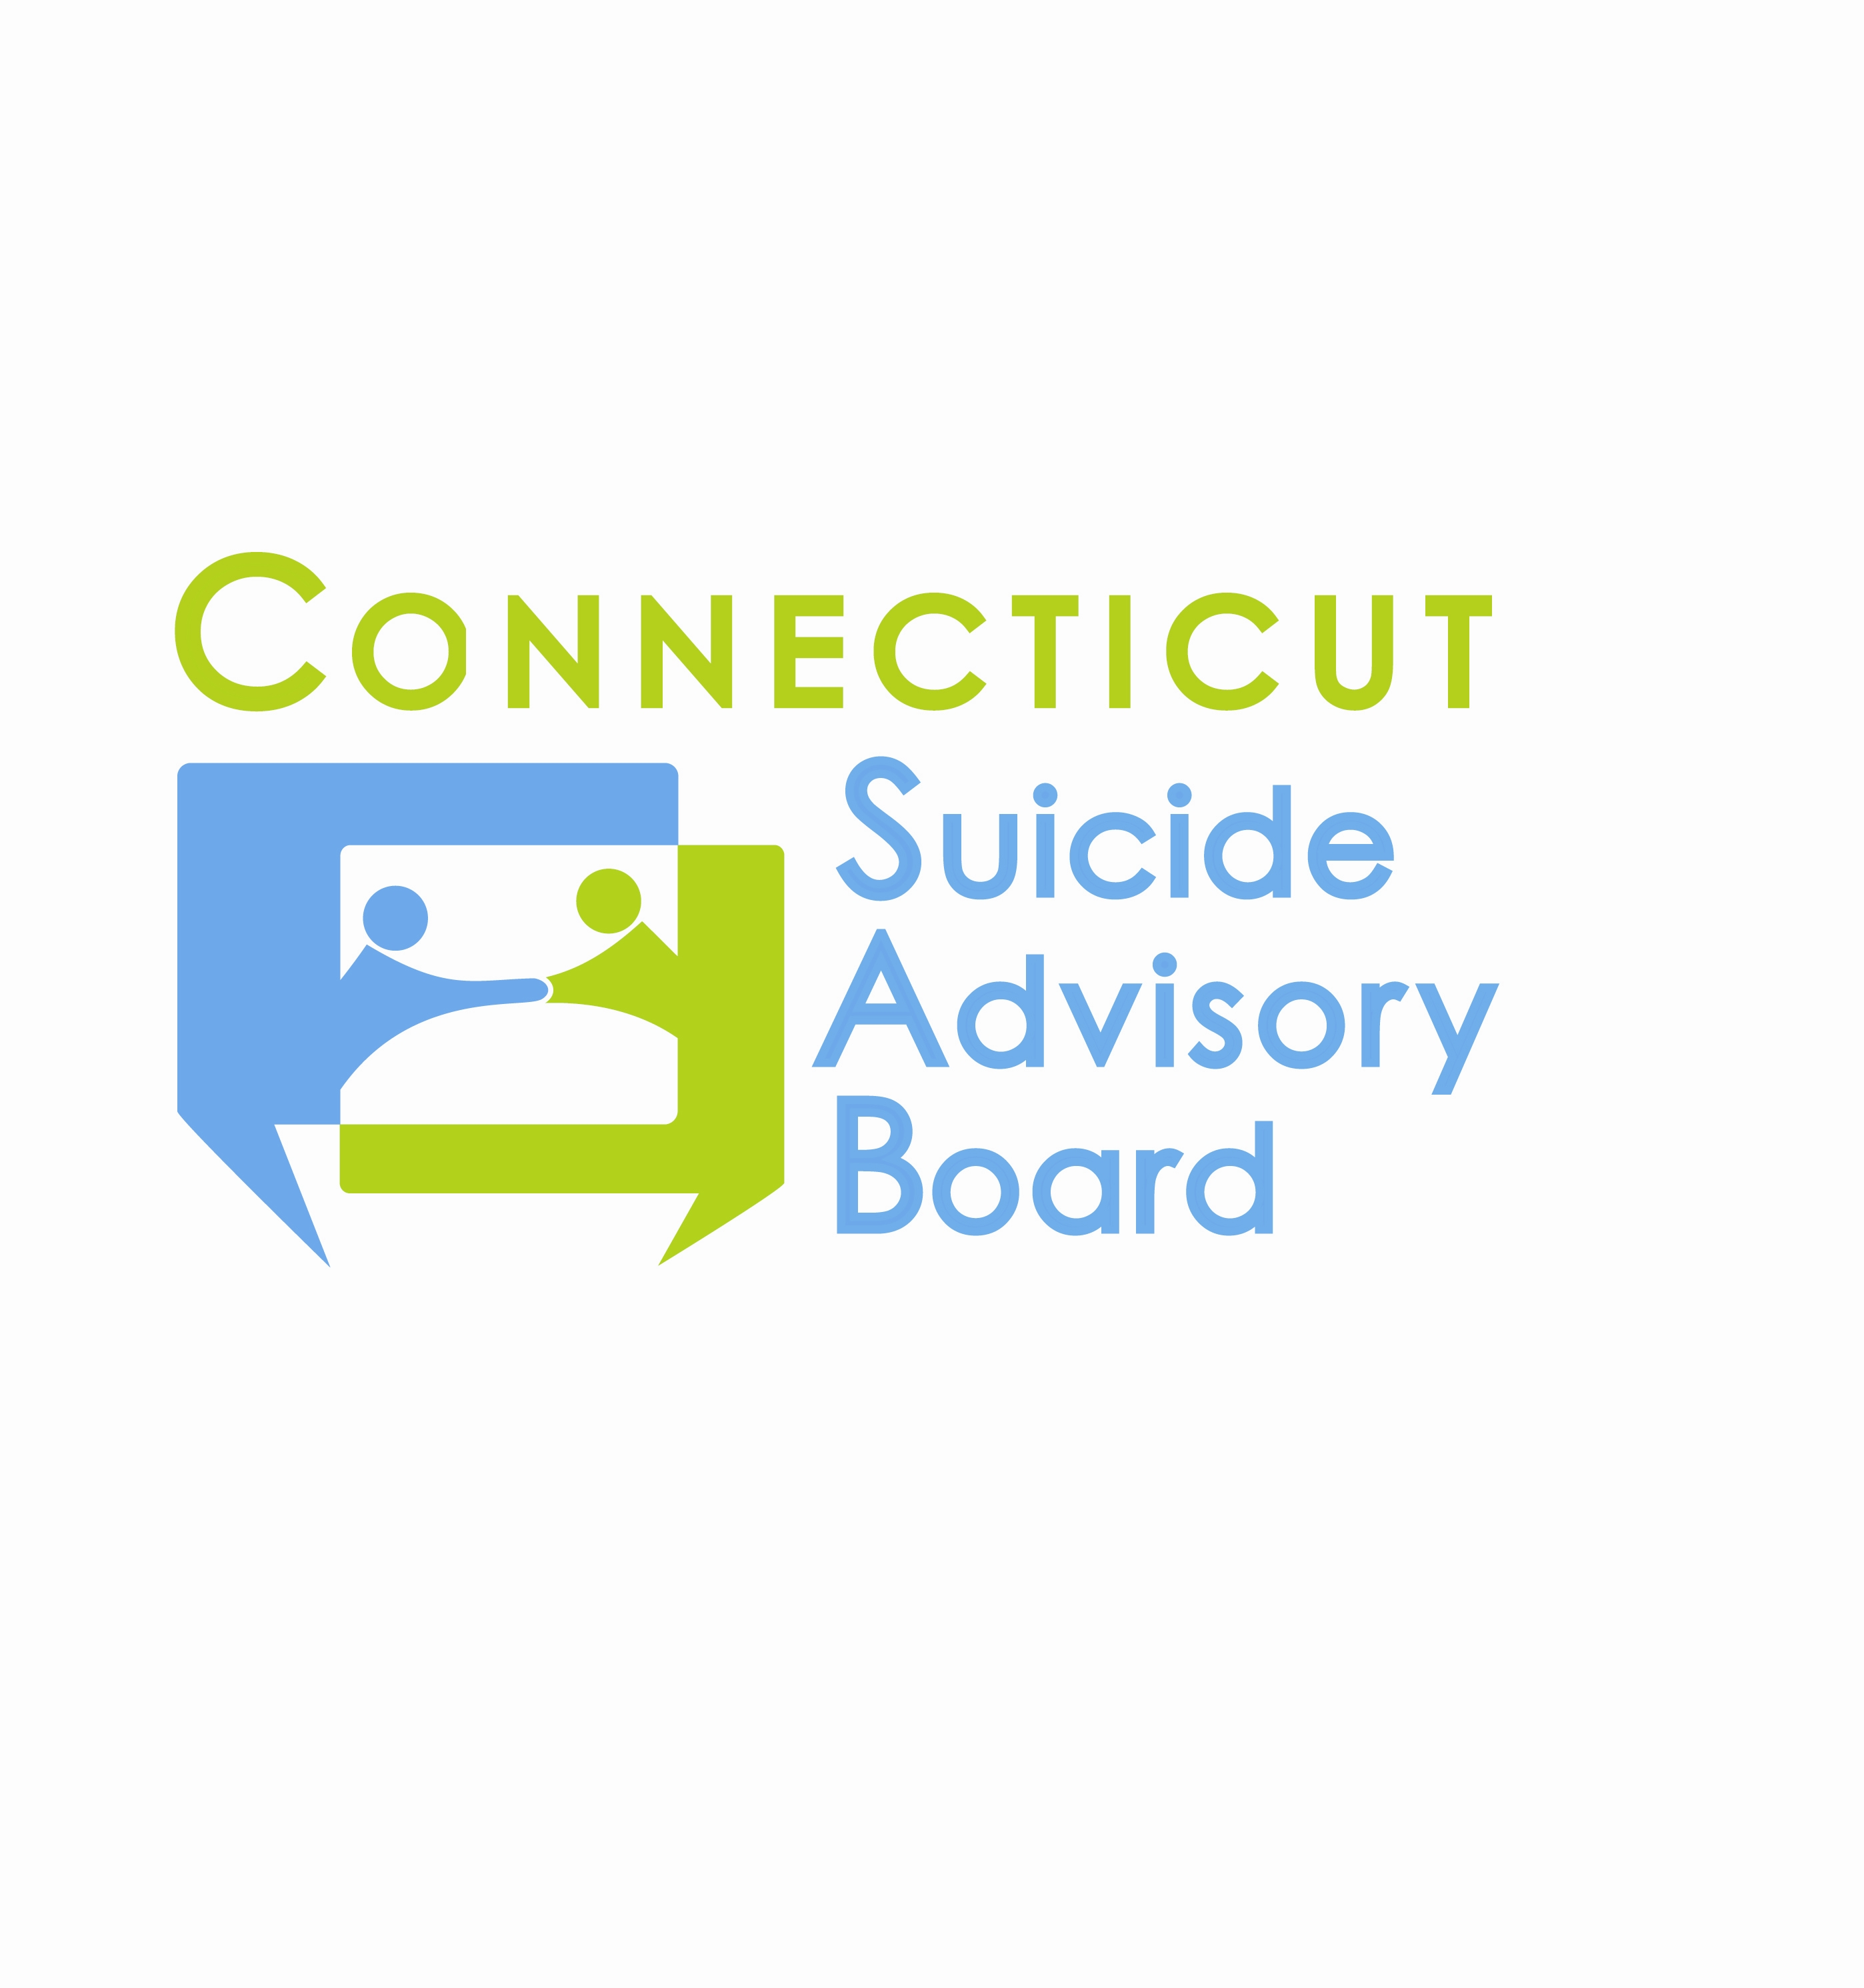
United Way of CT
1344 Silas Deane Highway, 4th Floor
Rocky Hill, Connecticut
May 9, 2013 9:00-11:00 AM

AGENDA

- Welcome & Introductions
- Presentation: CTSAB Annual Report
- Review of 4/11/13 Minutes and Follow-up
- Updates regarding priority areas & sub-committees
- Awareness Campaign/Website
  - PSA update
- Statewide Network
  - September-Annual Meeting and Suicide prevention month planning
    - Committee (Merge SP Mos. Committee with Media)
- Evidence-Based Practice Promotion
  - Training efforts and mini-grants
  - Intervention-Postvention Response Committee
  - Military Service Members Committee
- State Plan
  - Evaluation
  - Survey
  - AAS
- Updates
- 2013 Meeting Schedule: 2nd Th. of each month from 9-11 AM at the United Way of CT, Rocky Hill, CT:
- 6/13  - 7/11  - 8/8  - 9/12-Annual Meeting | - 10/10  - 11/14  - 12/12

