CT Suicide Advisory Board
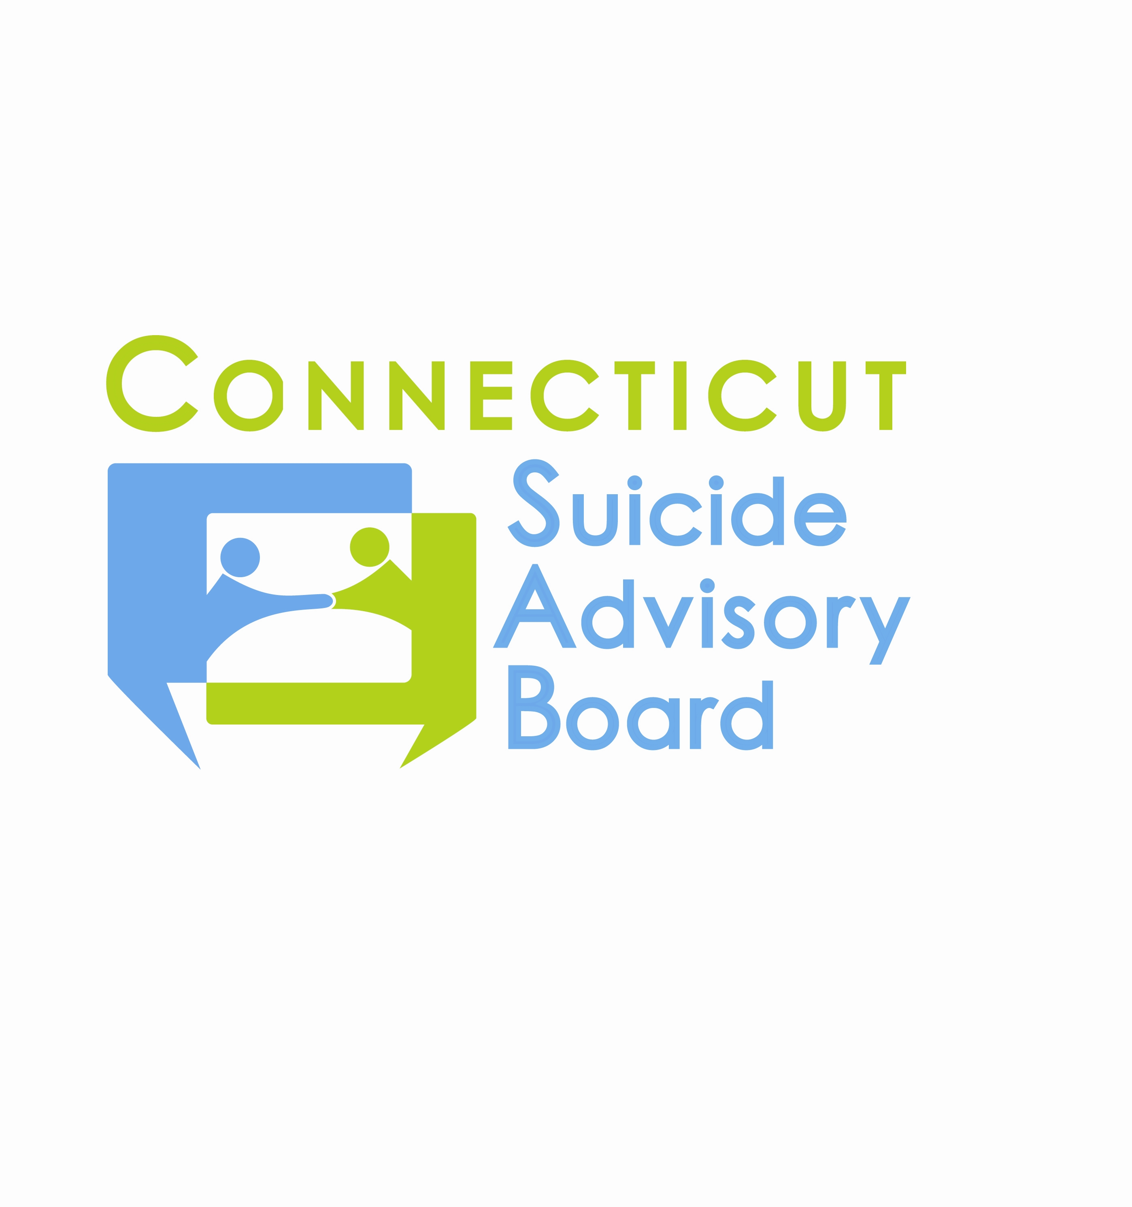
United Way of CT
1344 Silas Deane Highway, 4th Floor
Rocky Hill, Connecticut

February 14, 2013 9:00-11:00 AM

AGENDA

- Welcome & Introductions
- Presentation by Consultant Dr. Nina Heller on Revision of the CT Suicide Prevention Plan
- Hiring of Drs. Robert Aseltine, Jr. and Sara Wakai as additional consultants for data collection, analysis, and presentation for state plan and CTSAB
- Review of 1/10/13 Minutes and Follow-up
- Updates regarding priority areas
- Awareness Campaign/Website and T-shirt for AAS
- Statewide Network
- Evidence-Based Practice Promotion – QPR TOTs 1/9 & 1/10, Connect Postvention TOT 1/22-24, Three Rivers presentation and QPR training 2/7
- 2013 Meeting Schedule: 2nd Th. of each month from 9-11 AM at the United Way of CT, Rocky Hill, CT:
- 3/14- Presentation by Amy Hanoian-Fontana, Community Education Specialist, CT Poison Control Center
- 4/11  - 5/9  - 6/13  - 7/11  - 8/8 | - 9/12  - 10/10  - 11/14  - 12/12

